#Exercise 1

# Get the three test scores

test1 = float(input("Enter the first test score: "))

test2 = float(input("Enter the second test score: "))

test3 = float(input("Enter the third test score: "))

# Calculate the average

average = (test1 + test2 + test3) / 3

# Display the average

print(f"Your average test score is: {average:.2f}")

# Congratulate the user if the average is greater than 95

if average > 95:

print("Congratulations! You did an amazing job!")

#Exercise 2

# Get the user's age

age = int(input("Enter the person's age: "))

# Classify the person based on age

if age <= 1:

print("This person is an infant.")

elif 1 < age < 13:

print("This person is a child.")

elif 13 <= age < 20:

print("This person is a teenager.")

else:

print("This person is an adult.")

#Exercise 3

# Get the price of each item

item1 = float(input("Enter the price of item 1: "))

item2 = float(input("Enter the price of item 2: "))

item3 = float(input("Enter the price of item 3: "))

item4 = float(input("Enter the price of item 4: "))

item5 = float(input("Enter the price of item 5: "))

# Calculate the subtotal

subtotal = item1 + item2 + item3 + item4 + item5

# Calculate the sales tax (7%)

sales_tax = subtotal * 0.07

# Calculate the total

total = subtotal + sales_tax

# Display the results

print(f"Subtotal: ${subtotal:.2f}")

print(f"Sales Tax: ${sales_tax:.2f}")

print(f"Total: ${total:.2f}")

#Exercise 4

# Constants

shares_purchased = 2000

purchase_price_per_share = 40.00

commission_rate = 0.03

# Calculate the amount paid for the stock

amount_paid = shares_purchased * purchase_price_per_share

# Calculate the commission paid when buying the stock

commission_paid_buying = amount_paid * commission_rate

# Constants for selling

selling_price_per_share = 42.75

# Calculate the amount received from selling the stock

amount_received = shares_purchased * selling_price_per_share

# Calculate the commission paid when selling the stock

commission_paid_selling = amount_received * commission_rate

# Calculate the total commission paid

total_commission = commission_paid_buying + commission_paid_selling

# Calculate the net profit or loss

net_profit = amount_received - amount_paid - total_commission

# Display the results

print(f"Amount paid for the stock: ${amount_paid:.2f}")

print(f"Commission paid when buying: ${commission_paid_buying:.2f}")

print(f"Amount received from selling the stock: ${amount_received:.2f}")

print(f"Commission paid when selling: ${commission_paid_selling:.2f}")

print(f"Net profit/loss: ${net_profit:.2f}")

#Exercise 5

# Get user input

principal = float(input("Enter the principal amount: "))

annual_interest_rate = float(input("Enter the annual interest rate (as a percentage): "))

compounding_frequency = int(input("Enter the number of times interest is compounded per year: "))

years = float(input("Enter the number of years: "))

# Convert the interest rate to a decimal

r = annual_interest_rate / 100

# Calculate the final amount

A = principal * (1 + r / compounding_frequency) ** (compounding_frequency * years)

# Display the result

print(f"The amount of money in the account after {years} years is: ${A:.2f}")

Output:

1.

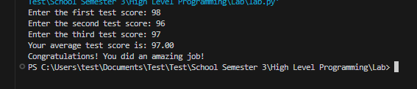

2.

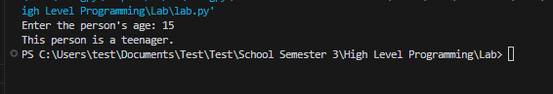

3.

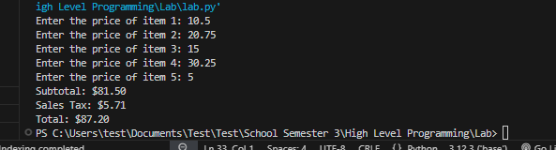

4.

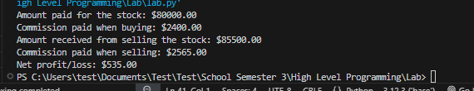

5.

